EXP NO :4 PROBABLISTIC CLASSIFICATION USING NAÏVE BAYES
13.02.26 (GAUSSIAN AND MULTINOMIAL NAÏVE BAYES)

SCENARIO 1: MULTINOMIAL NAÏVE BAYES
Confusion Matrix:
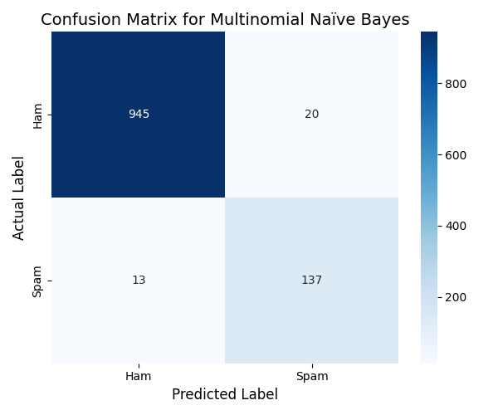

Top words influencing spam classification:
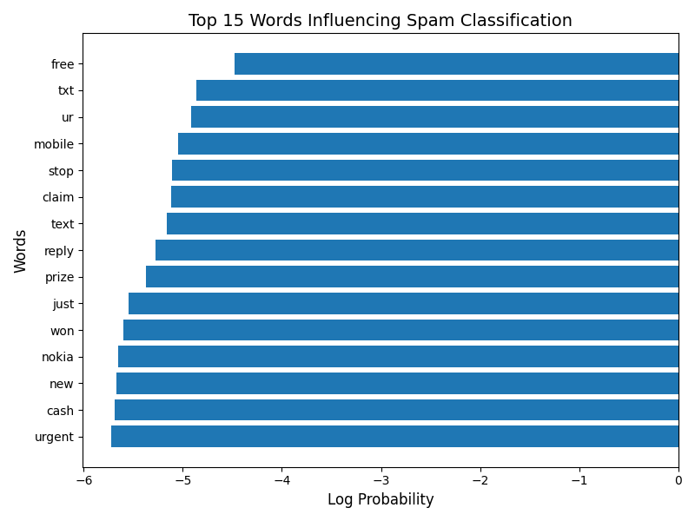
Word frequency comparison (Spam vs Ham):
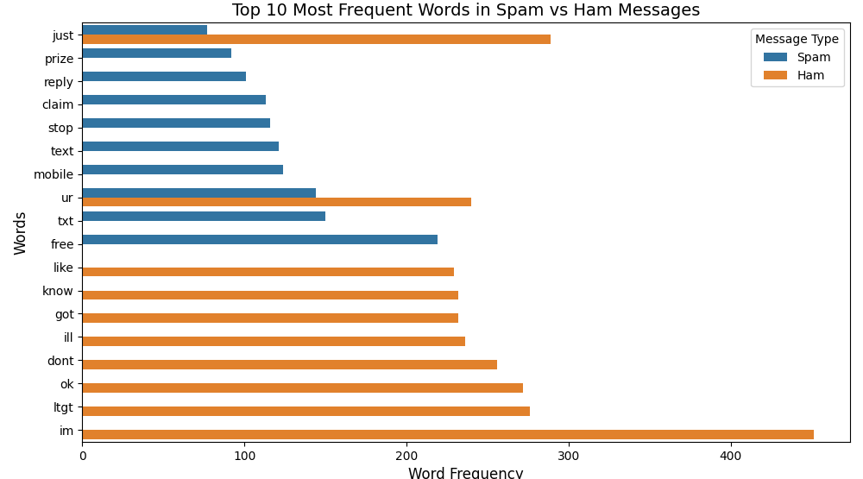

SCENARIO 2: GAUSSIAN NAÏVE BAYES
Confusion Matrix:
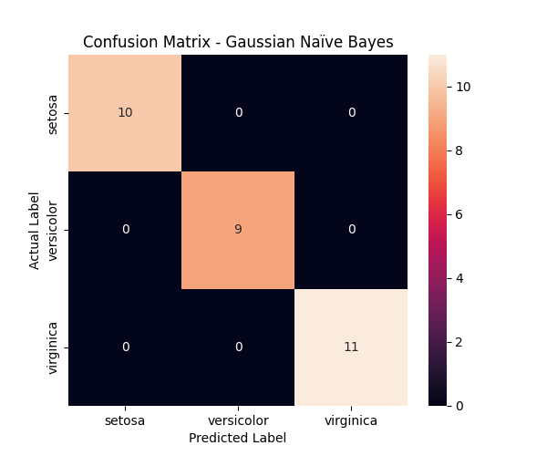

Decision Boundary Plot (using two features):
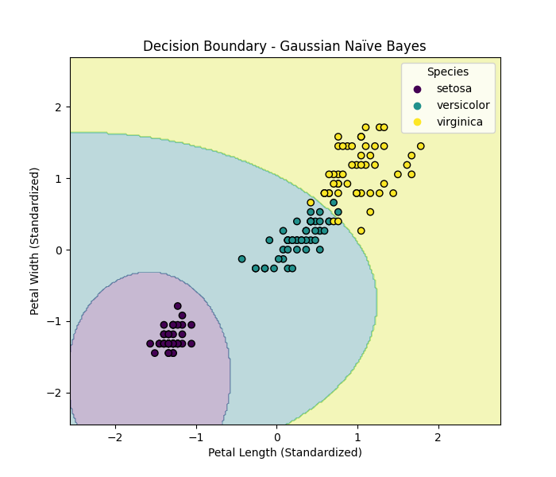

PROBABILITY DISTRIBUTION PLOT:
